**Youtube_view**

1. No signs of proper linearity, but we can see when likes percentage decreases, dislike percentage decreases

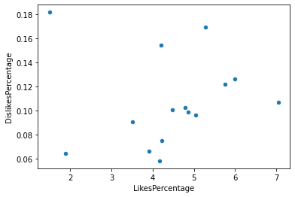

Likes percentage by category

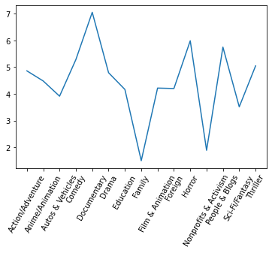

1. All the variables are positively correlated to each other

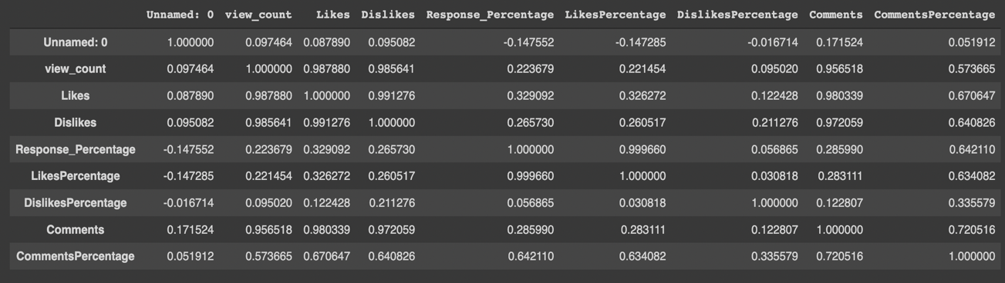

1. We can see that p value of “CommentsPercentage” at 95% confidence interval is not significant, hence we will remove this from the model

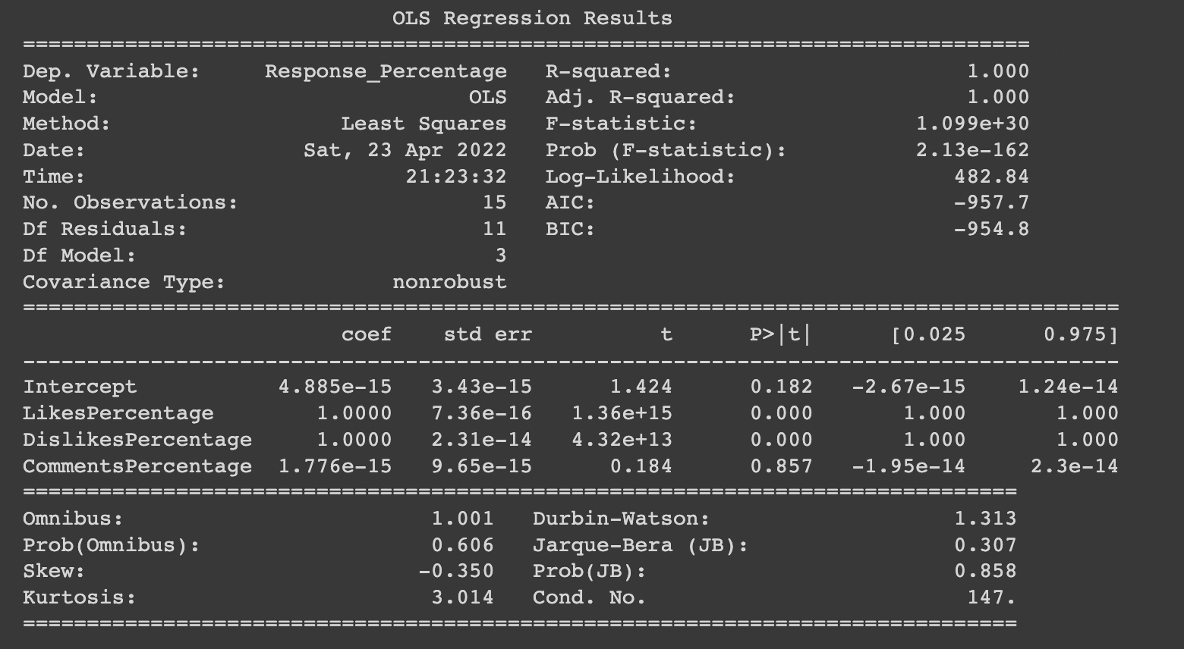

1. Response_Percentage = LikesPercentage + DislikesPercentage + 5.967e-15

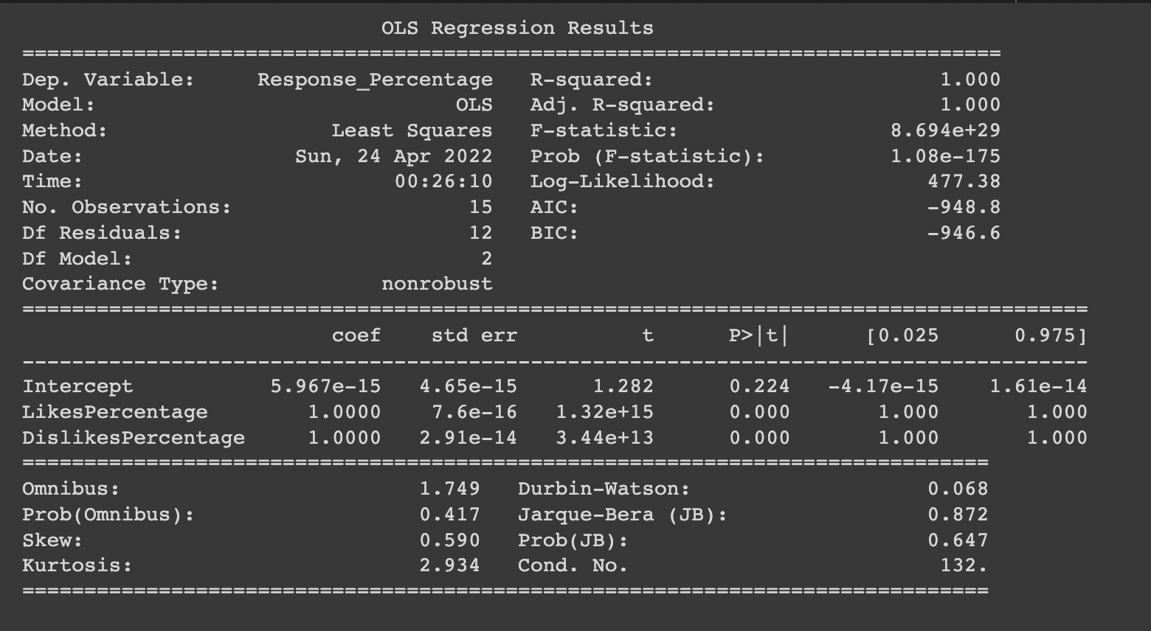

1. We can see that the p value at 95% confidence interval is more than 0.05 for Dislikes and Comments, hence it means these two variables can't decide whether the views will be more or not. Likes is a perfect variable to predict the number of views for a particular category
2. view_count = 17.6588*Likes + 3.309e+08

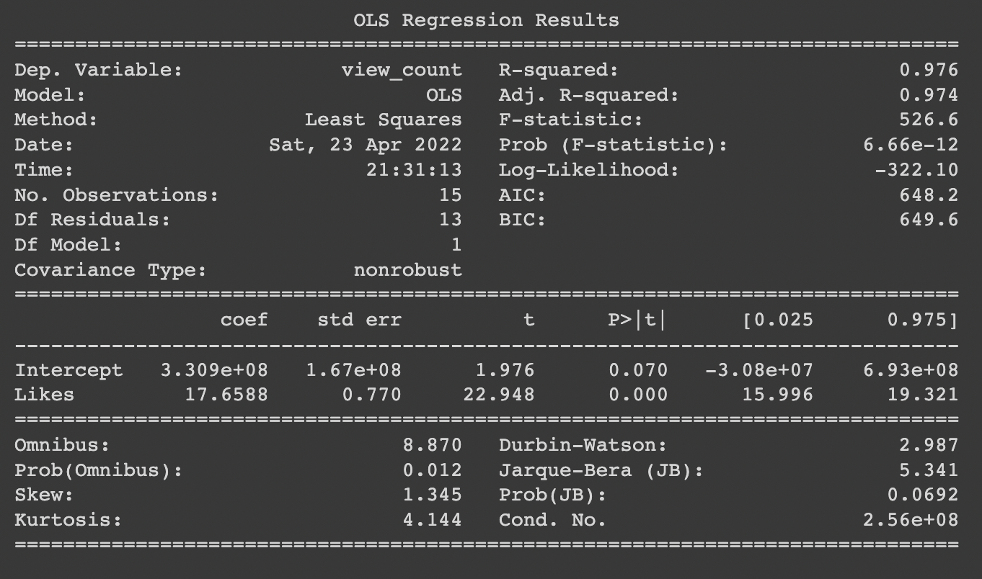

**Youtube_final**

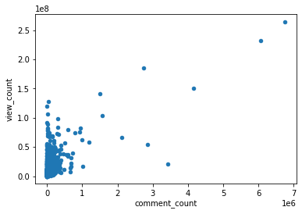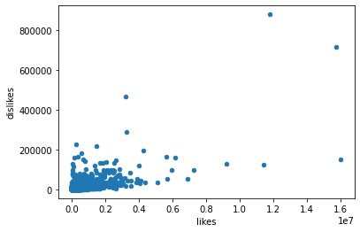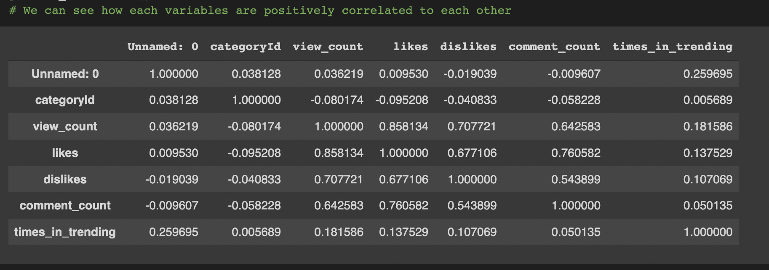

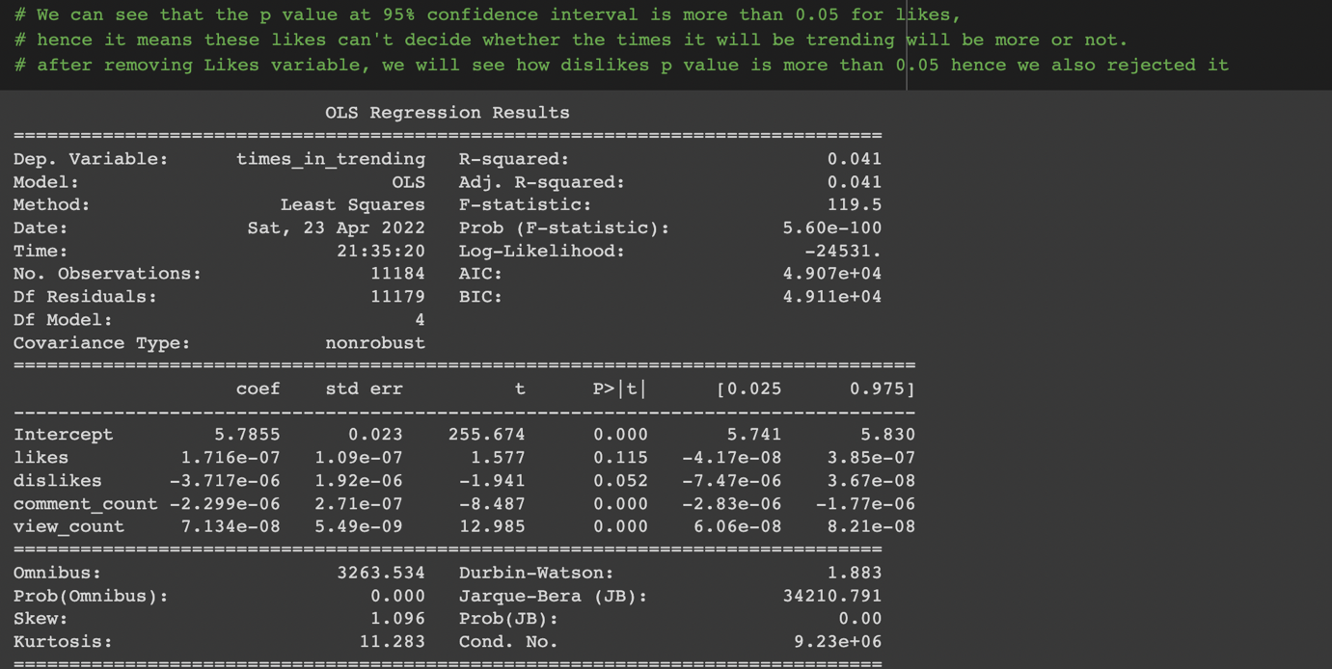

view_count = (-2.145e-06)*comment_count + (7.29e-08)*view_count + 5.7914

